To be submitted to: Learning, Breaking, Making: Analyzing Processes of Play,

Official deadline31st August **2021!**

I think we could also try to submit it first to *Creativity Research Journal* or *The Journal of Creative Behavior*

**Affordances in children’s building with LEGOS: An eye-trackings study**

## The building/creativity process

The building process was analyzed with the use of eye tracking and the video analyses. This results section will present analyses of the following:

* *Which bricks were firstly looked at and how long was the duration of the first fixation* as a measure of the attention drawn toward the bricks with canonical affordances.
* *Which were the most looked at bricks?* as a measure of visual exploration
* *Which were the most used bricks?* as a measure of action exploration
* *The number of brick-clicks* (BC) as a measure of convergent thinking. This one I haven’t plotted yet.

### Which bricks were *First-looked at*?

In the first ten seconds of each iteration children were asked to only look at the bricks. This procedure allowed us to analyse which bricks were *first looked at* and to explore whether across the three iterations the brick category that attracted initial attention has changed. Figure 11 gives an overview of the findings.

The bricks most frequently looked at first in Build1 are the 4YellowRound bricks. In most of the constructions, these bricks came to be used as some form of wheels. By Build3 there is little difference between which bricks were looked at first. On the other hand, the transparent brick was never looked at first. An average across all three builds reveals that the 3Orange bricks are most often looked at first. In prior exploratory studies in the lab, we found that initial attention is captured by the bricks with canonical affordances. In this study the initial attention was indeed captured by bricks with high affordances (i.e., the yellow bricks which were used as wheels). The structural bricks with less canonical affordances capture more children’s attention in subsequent iterations. Perhaps the nature of this task to ‘build a vehicle’ led children to first look at the most representative bricks for a vehicle, the wheels. In the subsequent iterations, as children had to follow the instructions to build in the most creative way they could they first looked at the structural orange bricks, suggesting a strategy change can be detected as fast as 10 seconds. The transparent brick was never looked at in the first iteration which could be due to its transparency that may actually detract from its noticeability.

Finally, the 2DarkRed bricks are not often looked at first initially, which seems almost counterintuitive since they are often used as a foundation of a vehicle.

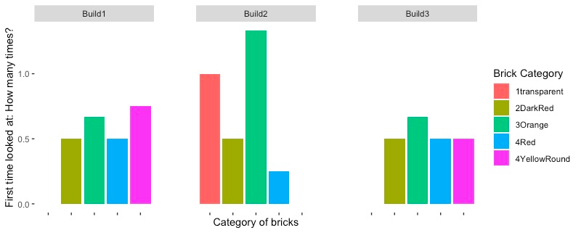

*Figure 11. How many times each brick category was looked at first?* Note that the total number of times the bricks were first looked at have been normalized by dividing the total number of looks per category by the number of bricks in that category. For instance, if there were four bricks in the same category, the total number of times children looked at any of the bricks from that category was divided by four.

### The first time each brick type is looked at (in the first 10 seconds), what is the duration of that fixation?

First-fixation duration indicates which brick category has been initially looked at longer, a potential indicator for the perceived novelty/familiarity of a given brick (Ryan, Hannula & Cohen, 2007). We found across participants that the first-fixation duration generally declined from Build1 to Build3, as the novelty of the bricks wore off (Figure 12). The 4Red bricks received the highest first-fixation durations in Build1. These bricks have some special properties as they allow perpendicular attachments, unlike other elements in the activity. In many of the constructions, the 4Red bricks were used as axle hubs for the four round yellow bricks to be used as wheels. This may be what the children realise when they first encounter them. It seems thus, that in the first build children’s attention was drawn by the potential of this interesting brick. Over the course of the three builds however, the first-fixation duration on this type of brick decreases to the second shortest, possibly due to a learning effect.

The 4YellowRound bricks also receive a long first-fixation duration in Build1. These were also the bricks which were most commonly looked at first in Build1. As noted above, the 4YellowRound bricks frequently become used as wheels. As with the 4Red bricks, their fixation duration decreased with each iteration. This may be explained by the fact that many children often couple these two types of bricks (axle and wheel).

In Build3, the structural bricks (2DarkRed and 3Orange) receive the longest first-fixation while the 4YellowRound and 4RedBricks receive the shortest first phase duration. This may suggest that in the last iteration, the attention shifts away from the special bricks to which the children already assigned a special purpose, to the more structural bricks. This might suggest that the apparent novelty of special bricks is lapsing towards the third iteration as the children seek attributes in generic bricks which could produce novel uses.

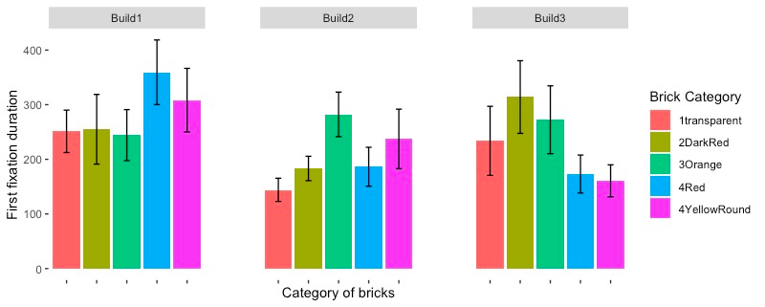

*Figure 12. Duration of first-fixation for each brick category.*

### Which were the MOST LOOKED AT brick categories?

By *most looked at* we mean the total number of times each brick category has been looked at, summed for each build and divided by the number of bricks in the same category. The most *looked at* bricks data are summarized in Figure 13.

In Build1, the transparent brick was looked at most often. This is consistent with our hypothesis that special affordance bricks may selectively capture the attention of the participants, and these bricks are consistently looked at in each build. However, when averaged across all builds, the 3Orange bricks are looked at the most, with the most looks in Build3. The 2DarkRed bricks also get a lot of visual attention in Build3. Thus, as the participants iterated, their attention appeared to shift towards the apparently more inconspicuous bricks. Considering that the raters identified the most creative builds in Build3, it appears that attention paid to these standard bricks may be a key indicator of how children developed creative solutions to the task.

The least looked at bricks overall were the 4Red and the 4Yellow bricks. They often clicked together early in the process, and were typically coupled as wheels and axles.

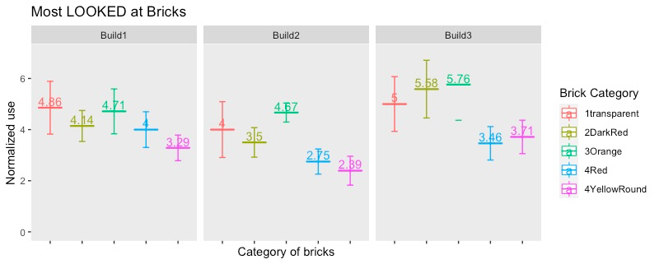

*Figure 13. Most looked at bricks by category (see legend), separated for each of the three iterations*

### Which brick categories have been MOST USED?

By *most used*, we mean the number of times in total each brick category has been used (picked up from the table or removed from the base and reused), summed for each build and divided by the number of bricks in the same category. The most *used bricks* data are summarized in Figure 14.

In Build1, children most often used the 3Orange and the 2DarkRed bricks. These bricks often formed the base of the vehicle and an increased number of uses for these bricks indicate children changed their minds more often about how to use them while building.

In Build2, children most often used the transparent brick, possibly because children try to diversify strategies and think about how to integrate this brick to the vehicle in a creative way.

In Build3, children used the 2DarkRed by far most often, with the 4YellowBrick, and the 3Orange bricks as the second and third most used, respectively. This may indicate that in this final iteration, children mainly focus on the base, with additional core elements (e.g., of body and wheels). Thus, it seems that exploring the structural bricks in the set (2DarkRed and 3Orange), along with those that have the most obvious function (4YellowRound), is critical for building novel and creative vehicles.This seems to become an increasingly clear strategy when children had to build creativity through several iterations.

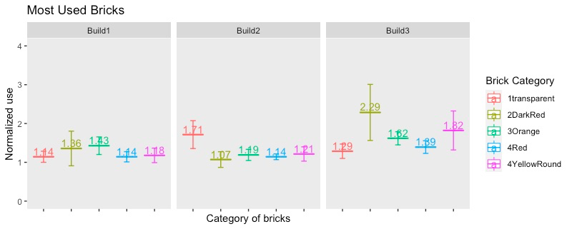*Figure 14. The most used bricks for each category brick (see legend), separately for each build.*

# 

# 

# Supplementary materials

Table 1. The detailed schema on how the codes were named and how the coding scheme was summarized in BORIS.

|  |  |  |  |
| --- | --- | --- | --- |
| **Behavior code** | **Behavior type** | **Key** | **Behavioral category** |
| l_4yr_1 | Point event | a | 4YellowRound |
| l_4yr_2 | Point event | s | 4YellowRound |
| l_4yr_3 | Point event | d | 4YellowRound |
| l_4yr_4 | Point event | f | 4YellowRound |
| u_4yr_1 | State event | h | 4YellowRound |
| u_4yr_2 | State event | j | 4YellowRound |
| u_4yr_3 | State event | k | 4YellowRound |
| u_4yr_4 | State event | l | 4YellowRound |
| l_4r_1 | Point event | 1 | 4Red |
| l_4r_2 | Point event | 2 | 4Red |
| l_4r_3 | Point event | 3 | 4Red |
| l_4r_4 | Point event | 4 | 4Red |
| u_4r_1 | State event | 7 | 4Red |
| u_4r_2 | State event | 8 | 4Red |
| u_4r_3 | State event | 9 | 4Red |
| u_4r_4 | State event | 0 | 4Red |
| l_2dr_1 | Point event | q | 2DarkRed |
| l_2dr_2 | Point event | w | 2DarkRed |
| u_2dr_1 | State event | o | 2DarkRed |
| u_2dr_2 | State event | p | 2DarkRed |
| l_3ob | Point event | z | 3Orange |
| l_3_om | Point event | x | 3Orange |
| l_3os | Point event | c | 3Orange |
| u_3ob | State event | b | 3Orange |
| u_3om | State event | n | 3Orange |
| u_3os | State event | m | 3Orange |
| l_1t | Point event | t | 1transparent |
| u_1t | State event | u | 1transparent |
| l_conf | Point event | i | Configuration |
| u_conf | State event | Ã¥ | Configuration |
| l_base | Point event | Ã¦ | Base |
| u_base | State event | Ã¸ | Base |
| BC | Point event | g | Point event |
| Acc | State event | v | Accidents |
| remove | Point event | r | Remove |
| l_minibase | Point event | 5 | Minibase |
| u_minibase | State event | 6 | Minibase |

**Legend for the coding scheme**

We distinguish between the bricks that are **looked at** and those that are **used.**

Codes starting with “l” such as: “l_4yr_1” refers to the **look at** codes.

Codes starting with “u” such as u_4yr_1 refers to **used.**

The numbers **“_1, _2, _3, _4”** at the end of the codes [l_4yr_1, l_4yr_2, l_4yr_3, l_4yr_4] keeps a history of the order in which bricks from the same category have been looked at For example, in case the participant looks at one of the four yellow round bricks for the first time, the behavior is marked with l_4yr_1, the second time a child looks at one of the other three yellow round bricks is marked with l_4yr_2, etc. When all the four yellow round bricks have been each looked at for the first time, the subsequent looks will take into account whether it is the first, second, third or fourth yellow round brick.

There are two behavior types: **point and state. Looked at bricks** are coded as points, single events in time. **Used bricks** are coded as states (with a start and an end event).

We distinguish moreover between **a base and** **a configuration**. **A “base”** is the collection of bricks that the participants keep building on to make a vehicle.

**A configuration** is a collection of two bricks that the participants put together and which is built separate from the base.

**Brick Click** was coded when two bricks are clicked together, or when a brick is clicked to a base

**Accidents** have been coded when bricks fall down from the base without the intention of the participant

**Remove** were coded as the eventswhen bricks are being removed from the base/configuration by the participants.